**MATLAB P2:**

**In reference to this math problem:**



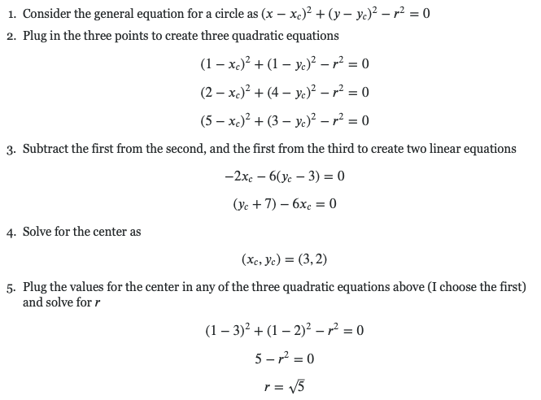

[**https://math.stackexchange.com/questions/213658/get-the-equation-of-a-circle-when-given-3-points**](https://math.stackexchange.com/questions/213658/get-the-equation-of-a-circle-when-given-3-points)

**Matlab:**

